Texas Higher Education Coordinating Board
Student Success Acceleration Program Implementation Grants
GRANT APPLICATION (FORM 3)

Applicant should pay close attention to the information provided in the RFA. Section highlights include: 2.1 (Max Number of Awards and Max Award Anticipated), 3.2 (Eligible Projects), 7.2 (Priority Criteria for Award Selection), and 7.3 (General Criteria for Award Selection).

Name of Program
[Insert response here]

Program Focus Area (Primary)
Select the focus area the submitted program best addresses from the drop-down menu below.
Choose an item.

Additional area(s) the submitted project supports (select all that apply)
Academic Support
Advising
Basic Needs/Wrap-Around Services
Finances/Cost
Mental Health and Wellness
Some College, No Credential Reengagement
Underserved Populations, including First Generation and Economically Disadvantaged Student Initiatives

Program Overview
Provide a brief overview of the submitted program including relevant information that describes how the program aligns with the primary focus area selected. (maximum 250 words)
[Insert response here]

Rationale for Funding
  - Provide an overview of the of the Applicant’s rationale to scale, enhance, redesign, or implement the submitted program. Include information and data on the program’s target student population(s), current outcomes, and other relevant information to make a compelling case for the Applicant to receive grant funds. (maximum 250 words)
[Insert response here]

  - In the table below, indicate the number of students served (if applicable) for AY21 and the anticipated number of students to be served in year one (AY 2022-23) and year two (AY 2023-24) for the submitted program considering the potential impact of grant funds.

Served AY 2021-22 | Anticipated AY 2022-23 | Anticipated AY 2023-24

  - How will the submitted program impact persistence, completions, and workforce transition metrics for the targeted student population(s) in AY 22 and AY 23? (maximum 250 words)
[Insert response here]

Goals and Main Activities

  - Provide the top three (3) goals of the submitted program. Goals should be reasonable and measurable.
G1 | [Insert Goal #1 here]
G2 | [Insert Goal #2 here]
G3 | [Insert Goal #3 here]

  - Use the table below to highlight key activities that will ensure full implementation of the submitted program (add additional rows as necessary).

Activity | Duration | Completion Date

Equity Framework

Use the information provided below in Figure 1.7 to answer the questions in this section.
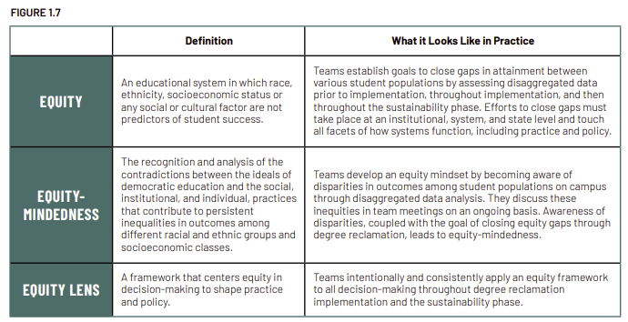

  - Why are equity terms and concepts important to implementing this program? (maximum 125 words)
[Insert response here]

  - How does the submitted program address equity for the targeted student population(s)? (maximum 125 words)
[Insert response here]

Additional Compelling Information (Required for budget requests $180,001 - $250,000). (maximum 250 words)
[Insert response here]

Priority Criteria (for additional points)

CATEGORY ONE
Applicant received an Accelerating Student Success Planning Grant and successfully submitted the required Action Plan and Student Success Programs Inventory Survey, as verified by THECB staff, for the same program for which they are seeking funding through the SSAP Implementation Grants.
Yes |  | No
CATEGORY TWO
Applicant is an eligible public, private/independent institutions of higher education that is federally recognized as “Minority Serving Institutions” (MSIs). “Minority Serving Institution” (MSI).
Yes |  | No
CATEGORY THREE
Applicant is an eligible public institution of higher education.
Yes |  | No

