WECM PROTOCOL MANUAL
Rev. October 2021

INTRODUCTION
Revised: 05/08, 08/10, 01/11, 05/18, 09/18
After a development period of three years, the Workforce Education Course Manual (WECM) became fully operational in 1998. It provides community and technical colleges with an inventory of pre-approved courses developed in close partnership with Instructional Specialists representing a wide variety of technical fields. It is supported by a mechanism for continually designing and updating courses, and it is complemented by a process for the implementation of courses developed to meet unique local need.
In 2017, it became apparent that the heavy lifting of course creation and maintenance had been completed. Course review and maintenance needed to be conducted by triggers and no longer needed to cyclical. Major responsibilities of the original WECM Project Personnel were incorporated into the role of THECB. The WECM Leadership Committee was renamed the WECM Advisory Committee.
Purposes of the WECM
- Contribute to the quality and consistency of workforce courses.
- Provide Texas colleges increased assistance and flexibility in responding to employer needs.
- Enhance the portability of credits and credentials for students.
- Provide increased access to workforce education degrees and career advancement.
- Facilitate articulation with other providers of education at both the secondary and post- secondary levels.
- Incorporate industry-established skill standards into Texas workforce education.
Maintenance Process
In an effort to be proactive and responsive to program and course needs, the goal is to utilize various triggers to maintain the WECM database of courses. Based on these triggers, faculty in the associated areas will be asked to provide input on new courses, revision of courses, and archival. The utilization of technology to facilitate this maintenance process will enhance the responsiveness to the field. By creating a curriculum based on marketable skill standards and maintaining continued relevance, colleges have a clear understanding of employer expectations resulting in workforce education courses that are relevant to employers and the workplace.
Guidelines for Instructional Programs in Workforce Education (GIPWE)
While the GIPWE and this manual are different in purpose and scope, they must be consistent. When revising WECM protocol, the WECM Advisory Committee (WAC) should consider the effect on the GIPWE and collaborate as appropriate with professional associations and follow Texas Higher Education Coordinating Board (THECB) procedures for GIPWE revision.

Purpose and Organization of Protocol Manual

Revised: 06/21
The intent of this manual is to convey the definitions, concepts, working policies and procedures that guide WECM maintenance. It reflects decisions upon which the WECM was structured as well as guidelines for maintenance operations. The WECM Advisory Committee continuously reviews the contents herein and assumes responsibility for currency.
For ease of reference and revision, the contents of this manual are arranged in discrete numbered units. Numeric designations reflect organizational structure. The first two digits designate the chapter; the second two, the section within a chapter. The last two digits are assigned to the specific protocol.
Contents
Chapter 1 WECM Advisory Committee 01-00
Role
Membership and Officers
Standing Subcommittees
Responsibilities
Communication
Chapter 2 WECM Courses 02-01
WECM Database, Course Structure, and 02-01-01
Components
Special Topics 02-01-02
Local Need 02-01-03
External Learning Experience 02-01-04
Mirror 02-01-05
Vendor & Generic Non-Vendor 02-01-06
Licensure, Certification, or 02-01-07
Accreditation Agencies
Chapter 3 WECM Database Review 03-01
Workshops 03-01-01
Course Revision & Addition 03-01-02
Administrative Course Correction 03-01-03
Archival 03-01-04
Chapter 4 WECM Workshops 04-01
Workshop Participants
Chapter 5 WECM Procedures 05-01
SCH Special Topic and Local Need 05-01-01
Review Subcommittee
Non-Credit Special Topic and Local Need 05-01-02
Review Subcommittee
Workshops 05-01-03

Protocol No. 01-00
Revised 05/18, 10/20, 6/21, 10/21

Chapter 1: Workforce Education Course Manual Advisory Committee

Role
As outlined in the Texas Administrative Code – Rule 1.220:
The Workforce Education Course Manual (WECM) Advisory Committee (WAC) is created to provide the Board with advice and recommendation(s) regarding content, structure, currency and presentation of the Workforce Education Course Manual (WECM) and its courses; recommendations regarding field engagement in processes, maintenance, and use of the WECM; and assistance in identifying new programs of study, developments within existing programs represented by courses in the manual, vertical and horizontal alignment of courses within programs, and obsolescence of programs of study and courses.
Membership and Officers
- Membership shall consist of faculty and administrators from public community, state, and technical colleges, as defined in TEC, §61.003, with demonstrated leadership in workforce education, and
- one (1) ex-officio representative from the Texas Association of College Technical Educators (TACTE), nominated by the TACTE Board; and
- one (1) ex-officio representative from the Texas Administrators of Continuing Education (TACE), nominated by the TACE Board; and
- one (1) ex-officio representative from the Texas Association of College Registrars and Admissions Officers (TACRAO), nominated by the TACRAO Board.
- The number of committee members shall not exceed twenty-four (24).
- Members of the committee shall select:
(1) the presiding officer, who will be responsible for conducting meetings and conveying committee recommendations to the Board; and
(2) the vice chair, who will succeed the presiding officer at the end of the presiding officer's term.
- Members shall serve staggered terms of up to three years, except an individual who serves first as vice-chair and then chair, who will serve a term of four years.
- After completion of the presiding officer’s term, they will remain in a Past Chair advising position.
The committee shall be abolished no later than January 31, 2025, in accordance with Texas Government Code, §2110.008. It may be reestablished by the Board.
Standing Subcommittees
Course Revision and Archival Subcommittee – Responsible for the review and final recommendation to the WECM Advisory Committee of recommendations of the Model Workshops or Program of Study Committees.
Credit Special Topic and Local Need Review Subcommittee - Responsible for:
  - The review of all credit Special Topic and Local Need courses submitted by the colleges on a quarterly basis. Based on college submissions, WECM comments, and other sources relating to industry changes, committee’s responsibilities include:
    - Course update recommendations to WAC
Deliverable – the ST/LN Spreadsheet of ST/LN courses submitted by the colleges, indicating:
        - whether a new course is recommended
        - current WECM course exists
        - leave as ST/LN
        - does not meet the guidelines of a WECM course
    - Evaluate trend and triggers to determine recommendation for a workshop to update courses in a particular area
  - The review and recommendation of new local need emerging technology rubric request submitted by institutions as they are received.
    - Review existing WECM courses and either recommend use of existing rubric or move request forward to TACRAO (Texas Association of Collegiate Registrars and Admission Officers)
    - In order to expedite this process, this review must be completed within 45 days of THECB receipt.
Non-Credit Special Topic and Local Need Review Subcommittee – Responsible for:
  - The review of all non-credit Special Topic and Local Need courses submitted by the colleges on a quarterly basis. Based on college submissions, WECM comments, and other sources relating to industry changes, committee’s responsibilities include:
    - Course update recommendations to WAC
Deliverable – the ST/LN Spreadsheet of ST/LN courses submitted by the colleges, indicating:
        - whether a new course is recommended
        - current WECM course exists
        - leave as ST/LN
        - does not meet the guidelines of a WECM course
    - Evaluate trend and triggers to determine recommendation for a workshop to update courses in a particular area
  - The review and recommendation of new local need emerging technology rubric request submitted by institutions as they are received.
    - Review existing WECM courses and either recommend use of existing rubric or move request forward to TACRAO (Texas Association of Collegiate Registrars and Admission Officers)
    - In order to expedite this process, this review must be completed within 45 days of THECB receipt.
Professional Development Subcommittee – Responsible for the review and final recommendation to the WECM Advisory Committee of all courses listed as professional development on a yearly basis.
WECM Comments Review Subcommittee – Responsible for the quarterly review of the WECM comments. The subcommittee will report any trend, triggers or emerging technology that could result in the need for a workshop to update, or create new, courses.
Subcommittees may choose to consult faculty, industry professionals, or others for support in order to provide effective recommendations.
The subcommittee chairs will report to the WAC regarding activities of the subcommittees and recommendations. All subcommittees should submit results of assigned work to the THECB staff three weeks prior to each WAC meeting. Once the work of the Standing Subcommittees is presented and approved by the WAC, a summary is presented to the Texas Higher Education Coordinating Board for final approval and adoption.
THECB is responsible for communication regarding the status of individual course submissions to the colleges.
Responsibilities
The WAC meets quarterly.
WAC meetings, subcommittees and task groups are called or cancelled by the WAC Chair on an as-needed basis.
Members of the WAC commit to the following:
- Participation in committee and sub-committee meetings and activities.
- Participation in a minimum of three committee meetings annually.
- These requirements are subject to review and exception by the Chair and Vice Chair
Communication
WAC Communication to the field
In addition to the comments process, the WAC provides information and announcements about the WECM via the THECB and professional association listservs.
WECM Comments
Employees of Texas community and technical colleges are encouraged to communicate regarding WECM courses via the THECB WECM Comments page located on the THECB’s website.
Comments and questions concerning general WECM observations, numbering, certification, licensing, course description, learning outcomes, suggested pre-requisites, etc., are addressed on the Comments page. THECB will acknowledge receipt of all comments within five (5) business days of submission.
Comments submitted via the website are sent electronically to all members of the WECM Comments Review Subcommittee. Subcommittee members will have ten (10) business days to send comment recommendations to the THECB. THECB will then notify submitter of the subcommittee’s recommendations.
Protocol No. 02-01
Revised 05/18

Chapter 2: WECM Courses

The Workforce Education Course Manual is made up of standard courses for use in teaching career and technical education courses across the state. The standardization of courses and components of each type of course is explained in this protocol.

Protocol No. 02-01-01
Revised: 05/18

WECM Courses – WECM Database

WECM Course Structure

All WECM courses contain standard components. Below is an example of an active WECM course from the database

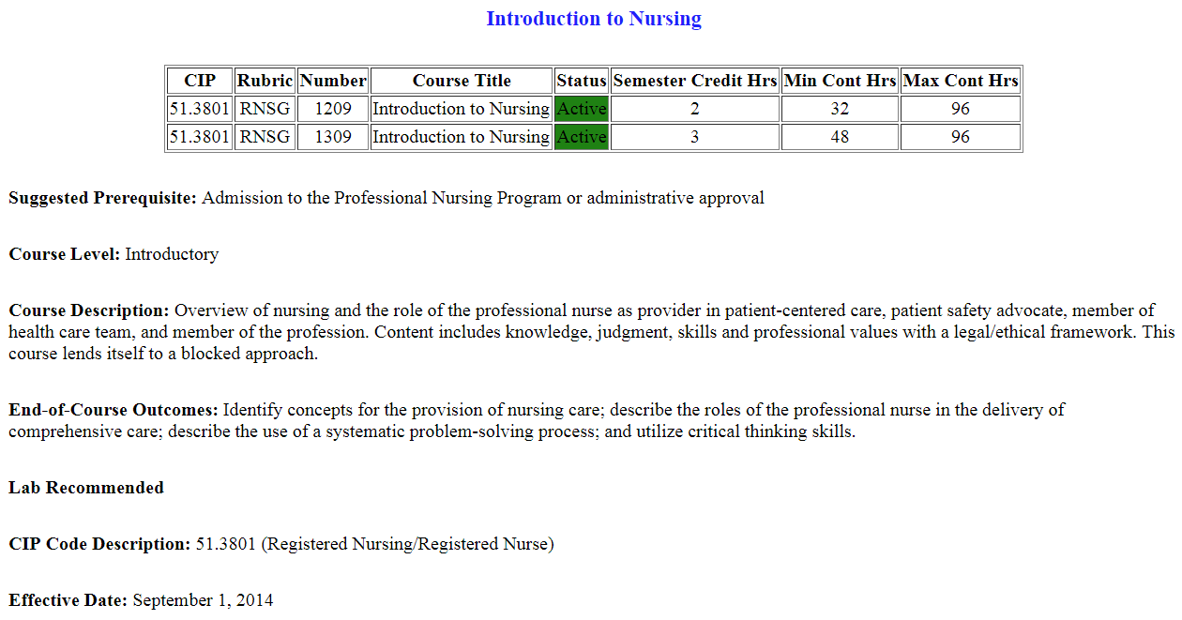
Components of a WECM Course:
Course CIP - The WECM is organized by six-digit CIP codes. Courses are assigned to CIP codes based on the alignment between course outcomes and title and CIP code descriptions. While Instructional Specialists or other practitioners may make recommendations, course CIP codes are assigned by THECB.
Rubric - Rubrics (prefixes) provide a common set of unique course designations for each occupational discipline. Each four-letter rubric (e.g. DFTG) identifies a cluster of skills and knowledge to be used in determining both course equivalency and degree applicability for transfer on a statewide basis. The rubric does not identify the only discipline eligible to use a course. Courses should be chosen based on course descriptions and learning outcomes, not on rubrics.
Rubrics are created in accordance with the following considerations:
- Prior use.
- Description associated the CIP Code.
- Association between rubric and description.
- Absence of vendor or product identification.
- Absence of unintended meaning. (i.e., slang, profanity)

New rubrics must be approved by the WAC in consultation with TACRAO.
Number - The four-digit number after the rubric indicates the course level, the SCH and/or CEU value, the course type, and the suggested sequence.
The first digit identifies course level. For SCH and CEU courses, an introductory course is denoted by a “1,” and an advanced course is denoted by a “2.” An intermediate course may be denoted with either a “1” or a “2.”
The second digit defines the SCH or CEU value. For example, a “ 3” indicates a three SCH course and a “0” denotes a non-credit course (that is, a CEU course.) Courses must follow the established ratios discussed in Chapter Three. Approved contact hour and credit hour combinations can be found in Table 4-1 of this chapter. The number of Continuing Education Units (CEU) awarded is calculated by setting ten instructional contact hours equal to one CEU.
The third and fourth digits establish the type of course and course sequence.
- 00-59 Lecture-Lab
- 60-63 Clinical
- 64-69 Practicum
- 70-79 Local Need
- 80-85 Cooperative Education
- 86-89 Internship
- 90-99 Special Topics
For both SCH and CEU courses, the published WECM rubric and number must be used in official college publications.
Course Title - Course titles are brief topical statements that are, with the exception of external learning experiences and professional certification courses, unique to each course. Instructional Specialists are encouraged to write succinct titles to accommodate various student information systems. The published WECM title for SCH courses must appear in college publications and on transcripts. For CEU courses, workforce marketing titles may be used to better describe the nature of the courses being offered. For CEU courses, workforce marketing titles may be listed in transcripts. However, all CEU mirror courses must use the published WECM title for the course. Course titles cannot contain product-, vendor-, or version-specific names unless the course is a vendor specific course.
Course Level - The course level indicates whether the course is introductory, intermediate, or advanced, as recommended by instructional specialists. The first digit in the course number specifies the course level, as described in the section titled “Course Rubric and Number.”
Suggested Prerequisite - If instructional specialists at a WECM Course Review Workshop or Program of Study Workshop agree on a course prerequisite, a specific list of prerequisite WECM or ACGM course(s), skill(s), or knowledge is included in the description.
Course Description - Course descriptions provide an overview of course content or subject matter. Colleges must use the complete WECM course descriptions for all SCH courses and CEU “mirror” courses, but they may enhance or add to the course descriptions as long as the enhancements are consistent with WECM-approved learning outcomes. The enhancements must not be so extensive that they result in a substantially different course. Colleges may revise the description of a course offered only for CEU provided that the integrity and intent of the course remains intact and the description is consistent with WECM-approved learning outcomes.
Generally, course descriptions contain no more than 100 words but not less than 25 words. If an abbreviation is used, the full written word or phrase must precede the shorter form. Each course description should begin with one of the following phrases:
Operation of | Mastery of | A study of | Topics Address
A course in | Projects in | Identification of | Examination of
Exploration of | Skill Development in | Practice of | Preparation of
Presentation of | Discussion of | Survey of | Operation of
An overview of | An introduction to | Fundamentals of | Advanced concepts of
Topics on | In-depth coverage of | Instruction in
Repair of | General principles of | A continuation of

End-of-Course Outcomes - End-of-course outcomes are the distinguishing feature of each WECM course. Minimum outcomes are intended for student attainment of specific competencies and are meant to be taught and measured for the award of either SCH or CEU.
End-Of Course Outcomes include the following characteristics:
“Heart” of a WECM Course
“Over-arching” outcomes that encompass enabling objectives Distinguish one course from another
May be augmented
Describe what students are able to demonstrate in terms of knowledge, skills, and attitudes upon completion of a course.
Focus on student behavior and use simple, specific action verbs to describe what students are expected to demonstrate upon completion of a course.
Measurable and/or observable
Contact Hour Ranges and SCH Options
Each course in the WECM has a suitable range of semester credit hours and/or contact hours necessary to master minimum learning outcomes. Ranges reflect an essential premise of WECM course construction, that is, minimum required outcomes are linked with maximum SCH and/or contact hour ranges to afford each college a choice of instructional strategies via lecture/lab components. In an effort to maintain instructional integrity SCH ranges are limited to two consecutive credit hours (i.e. 1-2, 2-3, 3-4, 4-5), however, it is acceptable to have only one option (i.e. only a 3 SCH option). SCH courses are assigned contact hour ranges based on the ratios outlined in the Table found in the GIPWE titled Lecture – Lab Credit/Contact Hour Combinations for SCH. Colleges must follow the established ratios for credit and contact hour assignments
A CEU course with fewer than 7 contact hours of instruction will not receive state funding unless the specific type and length of instruction are required by local, state, or national licensing, certifying, regulatory, or accrediting agencies. No lecture/lab CEU course can have more than 176 contact hours. CEU external learning courses follow the same contact hour limits as the SCH external learning courses.
Course Repeatability Clauses
Special Topics and CEU Professional Development courses may be repeated multiple times. These courses contain the following sentence at the end of the course description.

This course was designed to be repeated multiple times.
Other WECM courses that are designed to improve student proficiency through repeat enrollment may be designated as eligible to be “repeatable” upon recommendation by Instructional Specialists and approval by the WECM Advisory Committee. Individual institutions have the responsibility to appropriately document the multiple use of such courses. These courses contain the following sentence at the end of the course description.

This course was designed to be repeated multiple times to improve student proficiency.
Certain WECM courses that are designed to provide different course content through repeat enrollment may be designated as eligible to be “repeatable” upon recommendation by Instructional Specialists and approval by the WECM Advisory Committee. Individual institutions have the responsibility to appropriately document the multiple use of such courses. These courses contain the following sentence at the end of the course description.

This course was designed to be repeated multiple times if content varies.

Protocol No. 02-01-02
Revised: 01/05, 05/18

WECM Courses – Special Topics
Special Topics Courses
Available within each six-digit CIP Code, a Special Topics course should be used only when course content does not exist in a current WECM course. The Special Topics course is available for temporary use or transitional content. The college specifies discipline-specific learning outcomes for the Special Topics course. Topics may address recently identified current events, skills, and knowledge pertinent to the technical area and relevant to the occupational development of the student. Special Topics courses are identified by a “9” in the third digit of the course number. THECB approval is not required for the content of a Special Topics course. A College must submit the specific content taught in each of their Special Topics Courses to THECB prior to the end of the semester or quarter in which the course is offered. The specific topic is valid for two years, and the course content must be resubmitted every two years (or converted to a Local Need course) unless a new or revised WECM course with the same course content is made available.
A SCH Special Topics Course cannot have fewer than 16 contact hours or more than 112 contact hours. The course must follow the established ratios for contact hour and credit hour assignments. Allowable combinations are outlined in Table 4.1 - Lecture – Lab Credit/Contact Hour Combinations for SCH, Local Need, and Special Topics Course in the Guidelines for Instructional Programs in Workforce Education (GIPWE) . A range of contact hours and lecture/lab components is specified for each SCH value.
A CEU Special Topics course may not have fewer than 7 contact hours or more than 112 contact hours.
Special Topics courses are an important source of information regarding occupational trends and workforce education needs. These courses were designed to be repeated multiple times with different course content to improve student proficiency. A standing subcommittee will review Special Topics courses to determine and recommend if new courses should be added to or existing courses revised in the WECM.

Protocol No. 02-01-03
Revised 01/10, 03/10, 10/13, 05/18, 02/19, 10/20

WECM Courses – Local Need

Local Need Courses
Definition
A Local Need course may be used to respond to unique local or regional conditions or to regulatory changes. Content that will be offered repeatedly over several years is most appropriate for Local Need status. Evidence of need for this course must be substantiated by support from business and industry in a specified geographical area. A Local Need course must be submitted to the THECB and approved prior to instruction to qualify for state funding. Upon approval only that institution is authorized to use and report the specific Local Need course for two years.
Local Need courses are identified by a “7” in the third digit of the course number.
  - SCH Local Need courses cannot have fewer than 16 or more than 176 contact hours. The courses must follow the established ratios for contact hour and credit hour assignments. Allowable combinations are outlined in Table 4.1 - Lecture – Lab Credit/Contact Hour Combinations for SCH, Local Need, and Special Topics Course in the Guidelines for Instructional Programs in Workforce Education (GIPWE).
  - Unless it specifically addresses local, state, or national licensure, certification, regulatory, or accreditation requirements, a CEU Local Need course cannot have fewer than 7 contact hours. An institution that submits a CEU Local Need course for fewer than 7 contact hours must include specific information describing the requirement(s) addressed by the course.
  - CEU lecture/lab Local Need Courses cannot have more than 176 contact hours. CEU external learning courses must follow the same contact hour limits as the SCH external learning courses. CEU Local Need courses may be submitted with a range of 24 hours. For example, if a course is to be offered for 24, 36, and 48 hours, the approved range of hours will be from 24 to 48 hours. The lower number of the range cannot fall below 7 hours unless approved by the THECB as meeting local, state, or national licensing, certifying, regulatory, or accrediting agency requirement.
  - Emerging Technology Rubric Designation – Institutions submitting Local Need Course(s) that do not align with an existing WECM rubric should develop an appropriate rubric and submit the rubric as a component of the Local Need Course(s) or Program Application to THECB. New Rubrics must be approved by the WECM Advisory Committee in consultation with TACRAO. Due to the required research and approval process, a request for a new emerging technology rubric may delay LN approval.
If an institution requests a new rubric for an emerging technology, the following procedure is followed.
- Institution submits request through normal LN/ST request process.
- THECB staff follows current review procedure to ensure applicable courses do not already exist in the WECM.
  - If an applicable course already exists, the institution is notified that the LN/ST request is not approved.
  - If an applicable course does not already exist:
- The request is sent to the Credit or Non-Credit Special Topic and Local Need Review Subcommittee and simultaneously sent to the WECM Advisory Committee TACRAO representative.
    - The TACRAO representative:
        - Determines if the requested sequence of letters is available or makes a recommendation of a similar rubric for use.
        - Notifies THECB staff of recommendation.
    - The sub-committee reviews existing WECM courses and either:
        - Recommends use of existing rubric for the local need or use an existing course in the WECM – THECB will notify the college of this decision, or
        - Recommends a new rubric be used for the new technology.
- THECB Staff will notify TACRAO if the recommended rubric will be used or not.
- THECB Staff will notify the college of the final decision within 45 day of the original rubric request.
- THECB Staff will update the WECM Advisory Committee of these actions during the regularly scheduled meeting.
The following diagram illustrates the process for submission and review of emerging technology rubrics:
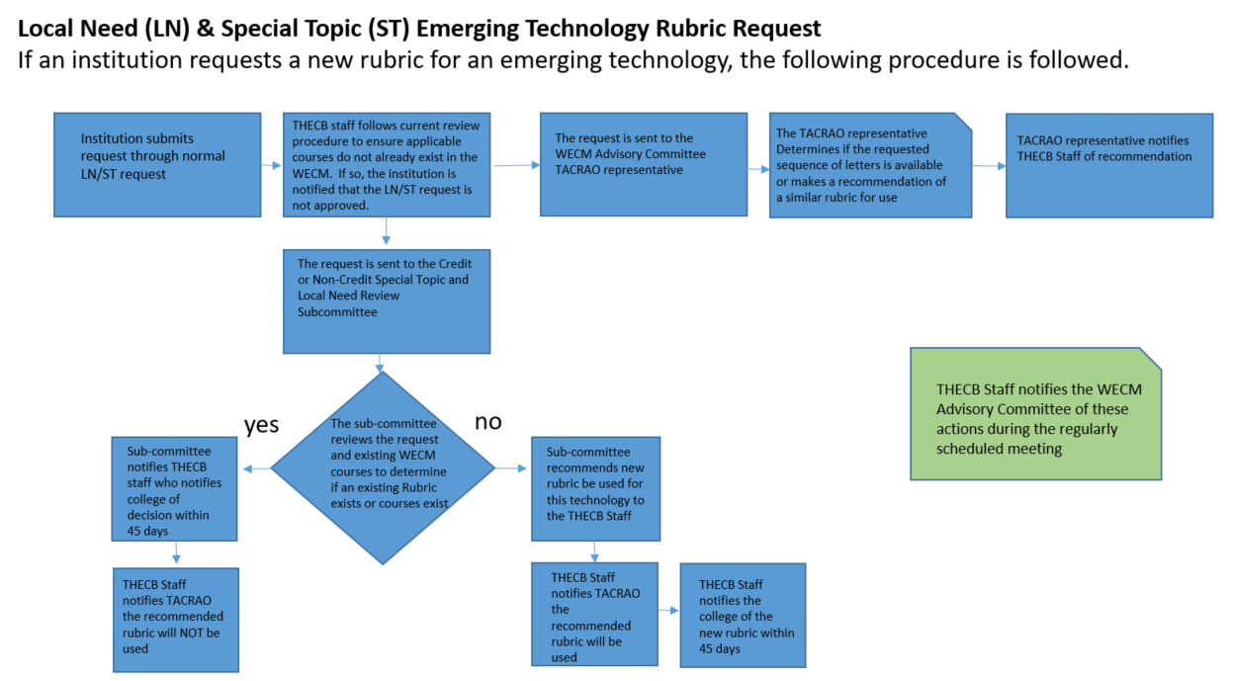
Local Need courses are an important source of information regarding occupational trends and workforce education needs. Local Need courses are evaluated to determine if new courses should be added based on the established triggers in Protocol 03-01 Each year, the THECB staff will send the approved local need course list to the institution for verification of continued use/renewal.
Protocol No. 02-01-04
Revised: 02/05, 01/09, 08/10, 05/18

WECM Courses – External Learning Experience

External Learning Experience Courses
An external learning experience is a competency-based learning experience that enhances lecture and laboratory instruction and is provided at work sites appropriate to the discipline. Time used to present or apply knowledge in a workplace setting is classified as external learning experience. The integration of knowledge gained through the external experience with previously learned concepts or practices, regardless of setting, time, or evaluation, is included in the instructional design of the external learning experience and is classified as external hours.
Advanced practice in a lab setting prior to performing an advanced or high-risk procedure may be included in this category. External hours may also include discussion of cases.
External learning experience courses—cooperative education, practicum (field experience), internship, and clinical experience are included in the WECM in each six-digit CIP code area as appropriate.
Guides and parameters for external experience courses are summarized in Tables 3.1 & 3.2 in the GIPWE. Instructional Specialists at WECM Course Review Workshops or Program of Study Workshops will determine the type(s) of external learning experiences that are appropriate for a particular discipline based on the following guides and industry standards.
If an institution has a Continuing Education (CE) program and offers an external learning course, the external learning experience course(s) should be submitted as a Local Need Course(s).
THECB staff will review the actual contact hours being taught for existing external learning courses and prepare a list for the WECM Advisory Committee or Subcommittee analysis.

Protocol No. 02-01-05
Revised 02/05, 01/09, 05/18

WECM Courses – Mirror

Mirror Courses
When a course may be delivered in either a SCH or a CEU format, the course is defined as a “mirror” course.
If a mirror course is reviewed, both the SCH and CEU format are affected; that is, if one is revised, the other is revised in the same way. The SCH and CEU courses are referenced below the rubric and number in the “Courses” description.
When a CEU mirror option to an already-approved SCH course is requested, the option will be added to the WECM unless otherwise prohibited.
Archiving one option of a mirror course and not the other is NOT advisable. For example, if mirror options exist (both CEU and SCH), then either, both should be kept active or both should be archived simultaneously.

Protocol 02-01-06

WECM Courses – Vendor-Authorized and Generic Non-Vendor

Vendor-Authorized and Generic Non-Vendor Courses
The WECM contains vendor-authorized courses written specifically to accommodate instructional requirements of commercial vendors. These courses were developed for use only by colleges that are authorized by a vendor. In most cases, vendor-authorized courses have generic non-vendor course alternatives. These non-vendor course alternatives contain similar outcomes as those in vendor-authorized courses; however, they are designed for colleges that are not vendor-authorized. Both vendor-authorized courses and the non-vendor course alternatives are flagged in the WECM.
If approved, the vendor name is inserted at the end of the vendor specific course description. For example:
Licensure/Certification: Microsoft Corporation.
Both vendor specific and parallel generic courses are flagged in the WECM with the following displayed above the course information, respectively:
Vendor Specific Course. To be used only by vendor authorized institutions.
A generic course is available as follows: (Generic course rubric/number) or (Not available)
Not a Vendor Specific Course.
A Vendor Specific Course is available as follows: (Vendor specific course rubric/number)

Protocol 02-01-07
Revised: 02/04

WECM Courses - Licensure, Certification, or Accreditation Agencies

Courses Required by Licensure, Certification, or Accreditation Agencies
The WECM incorporates licensure, certification or accreditation requirements through a variety of approaches. These include standard SCH and CEU courses, CEU courses with less than 7 contact hours, and CEU Professional Development Courses.
  - WECM courses designed to address the specific requirements associated with licensing, certification, or accreditation are developed on an “as needed” basis. These courses include the name of a licensing, certifying, or accrediting agency, beneath the SCH and/or CEU learning outcomes.
  - Workforce continuing education courses with fewer than 7 contact hours of instruction are included in the WECM when specific type and length of instruction are required by local, state, or national licensing, certifying, regulatory, or accrediting agencies.
  - A CEU professional development course with a generic description and a range of 7-24 contact hours is available in appropriate CIP codes and rubrics to assist colleges in meeting mandatory licensure and certification continuing education requirements. These courses are designed to be repeated multiple times to improve student proficiency and to enable practicing professionals to receive mandatory continuing education. Title for professional development courses will begin with “Professional Development: . . .” The course number for Professional Development courses will be 20xx.
To revise or create a course required by a licensure, certification, or accreditation agency, a college submits a Local Need application or a Special Topics course form with justification that includes a description and length of the specific course. The course must be required by a local, state, or national licensing, certifying, regulatory, or accrediting agency.
Upon verification of the external requirement, the Coordinating Board forwards the course to the appropriate WAC Subcommittee. The subcommittee assures that the course meets WECM course protocol requirements and makes recommendation for inclusion to WAC.

Protocol No. 03-01
Revised 10/13, 05/18, 6/21

Chapter 3 WECM Database Review

WECM Courses may be reviewed as indicated by “triggers” as outlined below.
- Program of Study Committee recommendations.
- Emerging and/or changing technologies.
- Business/industry standards.
- State and national credentialing requirements.
- The legislative body and the leadership of community and technical college administrators.
- Employer defined skill requirements
- WECM Comments
- Identified needs as indicated by statewide curriculum projects.
- Response to the Texas Higher Education Coordinating Board communication to the field requesting WECM updates. (This request will be sent each Spring.)
- Recommendation of one of the Standing Subcommittees and the WECM Advisory Committee
WECM Course Review Workshops are conducted as needed.

Protocol No. 03-01-01
Revised 3/10, 8/10, 1/11, 10/13, 05/18, 6/21,10/21

Course Review Workshops

WECM courses are added, reviewed, revised or archived through WAC subcommittee review, workshops conducted through the WECM maintenance process, and/or through the Program of Study development process. Other triggers are outlined above. Various modes of delivery are available to assure the proper treatment of all courses. Workshops may be held face to face or via an electronic medium. Industry professionals may be included in any of the workshops.
To assure consideration of all courses, a one- to two-day Course Review Workshop is held. At all Workshops, a team of Instructional Specialists is led by a workforce education expert who serves as a lead facilitator or facilitator. This requires a broad representation of Instructional Specialists, as nominated by instructional administrators. The team members must rank high on teaching skills and knowledge of subject areas; be involved in program development and course design (e.g. state authorized Program of Study); remain current in the discipline; and work cooperatively with colleagues.
Additionally, specialists are selected in consideration of obtaining equal representation from small, medium, and large colleges and from diverse regions of the state. Gender and ethnicity are important in the selection process.
A workshop would normally be triggered by a substantive number of WECM comments, special topics or local need course submissions for a particular field, or response to a request from THECB for necessary updates. If the triggers have identified an emerging or changing technology, industry representatives will be included as part of the development workshop.

Protocol No. 03-01-02
Revised: 10/13, 05/18

Course Revision & Addition

Course Addition
New SCH and CEU courses may be added to the WECM upon the recommendation of Instructional Specialists reaching consensus during a course review workshop or Program of Study committee meeting. Justifications for a new course include new technology; new licensure, certification, or accreditation requirements; and/or a large number of similar Local Need and Special Topics courses submitted. A newly written course must not replicate an existing WECM course. A new course may be used as soon as it is officially posted on the WECM website.
Course Writing Process

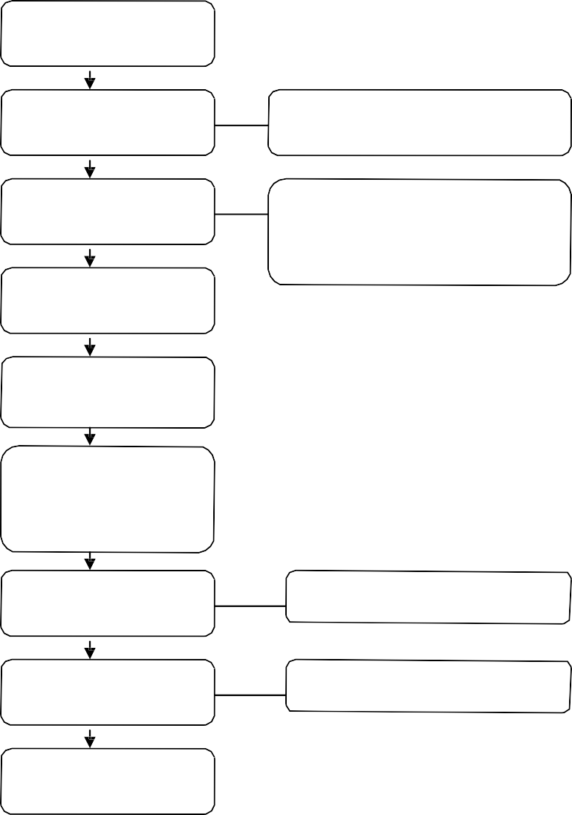
Sign Agreement Form
Identify the Topic
Determine the
Course Level
Determine level first to define the
appropriate Bloom’s verbs.
Develop Course
Outcomes
Courses should be broad enough to
allow local flexibility and control, but still communicate the content of the course.
Write Course
Description
Create Course Title
Assign Contact Hour Range and SCH Value
Recommend Course
Rubric
See Rubric Protocol
Assign Course
Number
See Course Numbering Protocol.

Course Revision
Instructional specialists at Program of Study meetings or WECM Workshops may make recommendations for course revisions or additions. Such elements as course outcomes, course descriptions, title, contact hour range, SCH and CEU options, CIP code, and rubric. After the instructional specialists reach consensus, the revised course is recommended to the WECM Advisory Committee for inclusion in the WECM. The course is available for use when posted by the THECB at the WECM website.

Review Course Outcomes
Measurable?
Properly written using Bloom’s taxonomy? Grammar, spelling, punctuation, etc?
Adhere to level of course.
Review Course Description
Adequate reflection of the learning outcomes?
Overview of course content Grammar, spelling, punctuation, etc.?
Review Course Title
Reflects course goals
Appropriate length
Review Contact Hour Range
and SCH/ CEU Options
Appropriate for the learning outcomes of the course?
Allows for maximum flexibility?
Confirm CIP, Rubric, Number
CIP and Rubric?
Does the number concur with protocol?
Concur on Revisions
Create New
Course
No Change
Revisions
Needed
Archive in
WECM

Protocol No. 03-01-03
Revised: 10/13, 05/18, 09/18

Administrative Course Correction

Administrative corrections may be made to WECM courses by the THECB Staff. . These corrections are generally minor, such as grammatical or spelling changes. In rare instances, the THECB staff may remove a course for administrative reasons if deemed inconsistent with WECM Protocol. A list of these changes will be provided to the WAC at each quarterly meeting.

Protocol No. 03-01-04
Revised 10/12, 02/13, 05/18

Archival

Archiving Courses
Archiving is the process of removing an unused, obsolete, duplicate content, or inadequate course from the WECM. Duplicate courses should also be considered in the archiving process. A course may be archived through one of three processes: Non usage/industry relevance archiving, recommendation from the Program of Study Advisory Committee, or a Course Review Workshop. An archived course is no longer available for use and is no longer eligible for state reimbursement.
For future reference, THECB maintains a web accessible database of archived courses that provides a history of WECM courses and a record of the archiving cycles.
Archived Pending Course: A list of courses that will be archived at the end of the next cycle will be posted on the WECM website before the courses are removed from the WECM course inventory. These are “archive-pending” courses. Generally, an archive-pending course will remain active for a minimum of one annual cycle beginning September 1 and ending August 31. In some circumstances, a different schedule will apply, but the expiration date for the course will be provided on the WECM inventory.
During a WECM Workshop or Program of Study Committee meeting, Instructional Specialists examine courses and may recommend disposition of courses to the WECM Advisory Committee. Standard reasons for archiving courses are: Obsolescence, unused during the past three years as evidenced by the THECB Data Frequency Report, duplicated outcomes, developmental level, outdated, and non-conformance to WECM protocol. Courses to be archived are flagged and posted on the WECM web site when workshop results are posted.
THECB procedures allow the WECM Advisory Committee to override the recommendations of the Instructional Specialists if a compelling reason with justification for doing so is presented. Based on field comments or other information, the WECM Advisory Committee may elect to leave courses in the WECM that would otherwise be archived. If a course is approved for removal from the WECM, that course is flagged in the WECM and archived on August 31 of the following annual cycle.
In addition to archiving conducted through the WECM course review and Program of Study process, courses that have not been used for five years or in consideration of industry relevance will be flagged for archiving each January. These courses are archived effective the following August 31st.

Protocol No. 04-01
Revised 05/18, 10/21

Chapter 4: WECM Workshops

Workshop Participants: Qualifications, Roles & Responsibilities

Instructional Specialist
Qualifications:
- Community or technical college instructor who is considered to be an expert in the specific courses being reviewed and who has currently taught these courses.
- Nominated by the college administrator.
- Team player.
- Willing to represent the state in a particular area of expertise.
Role and Responsibilities:
- Review all courses assigned and related documentation prior to workshop.
- Collaborate with workshop team to make changes to existing course(s) if necessary.
- Collaborate with workshop team to determine if any course(s) need to be archived.
- Collaborate with workshop team to write new course(s) if necessary.
- Review Special Topics/Local Need course submissions and, if necessary, write new course(s).

Lead Facilitator
Qualifications:
- A member of the WECM Advisory Committee or someone who has substantial and contemporary experience working with WECM workshops.
- Knowledge of WECM Protocols, standards and practices.
Role and Responsibilities:
- Coordinate with THECB WECM Staff in the planning, scheduling, and overall preparation for WECM Workshops.
- Prepare preliminary course review materials, prepare and present the Instructional Specialist Orientation, disseminate course data to facilitators, and coordinate with facilitators on workshop strategies.
- Assists the facilitator and the team when guidance or mediation is needed.
- Deliver final course review material from the teams to THECB WECM Staff.

Facilitator
Qualifications:
- Community or technical college workforce educator with workforce program leadership experience.
- Previous workshop experience and/or training.
- Knowledge of WECM Protocols, standards and practices.
Role and Responsibilities:
- Review all courses, data, and information related to the team meeting.
- Review and disseminate preliminary course review materials for their team.
- Facilitate and/or document team decisions.
- Deliver final course review material from the team to the lead facilitator or THECB WECM Staff.

CE Expert
Qualifications:
- Expertise in Texas Community and Technical College Workforce Education and continuing education guidelines and practices.
Role and Responsibilities:
- Participate with Instructional Specialists in reviewing WECM courses.
- Provide information regarding CE course needs.
- Serve as resource regarding CE structure and applications.

Protocol No. 05-01
Added 06/21

Chapter 5: WECM Procedures

Protocol No. 05-01-01
Added 06/21

SCH Special Topic and Local Need Review Subcommittee

As part of the review process, Special Topics and Local Needs Course submissions review is completed by a WECM subcommittee.

The review of these courses is completed using the same processes of a regular workshop; however, virtual/online meetings may be used to facilitate the process.

THECB Staff prepares a spreadsheet of Special Topics/Local Needs courses at least quarterly, or more frequently as needed based on the number of courses submitted. The spreadsheet and THECB documentation (Special Topic/Local Need submission) is forwarded to the Chair of the subcommittee.

The subcommittee will review the courses to determine:

if courses need to be written based on number of similar submissions – utilizing content experts from the field, courses are written and these recommendations are submitted to WECM Advisory Committee for review.

if course should remain ST/LN

if a current WECM course exists that could be used in place of the ST/LN

if course does not meet WECM guidelines

At each quarterly WECM Advisory Committee meeting, the subcommittee Chair will report to the WECM Advisory Committee regarding activities of the committee and any emerging trends noted in the review.

The subcommittee will submit the following deliverables:

The ST/LN spreadsheet indicating whether a new course is written, leave as ST/LN, current WECM course available or does not meet WECM guidelines.

Recommended new courses.

The WECM Advisory Committee will review new course recommendations to determine if this is a trigger for a full workshop and for approval to be included in the WECM database.

All approved courses will be uploaded to the WECM database.

Protocol No. 05-01-02
Added 06/21

Non-Credit Special Topic and Local Need Review Subcommittee
As part of the review process, Continuing Education Special Topics and Local Needs Course submissions is completed by the TACE/WECM committee. This Committee consists of a Chair and team of CE professionals. The chair is the past-president of TACE and the team members are nominated by the TACE Board to serve a term of two years. Each member represents one of the six Texas regions. Efforts for regional representation will be the priority, however members with extensive WECM and Continuing Education knowledge may be considered for membership by the TACE Board.
The review of these courses is completed using the same processes of a regular workshop; however, virtual/online meetings may be used to facilitate the process.

THECB Staff prepares a spreadsheet of CEU Special Topics/Local Needs courses at least once a quarter, or more frequently as needed based on the number of courses submitted. The spreadsheet and THECB documentation (CEU Special Topic/Local Need submission) is forwarded to the Chair of the TACE WECM Committee.

The TACE WECM Committee will review the courses to determine:

if courses need to be written based on number of similar submissions – utilizing content experts from the field, courses are written and these recommendations are submitted to WECM Advisory Committee for review.

if course should remain ST/LN

if a current WECM course exists that could be used in place of the ST/LN

if course does not meet WECM guidelines

At each quarterly WECM Advisory Committee meeting, the TACE WECM Committee Chair will report to the WECM Advisory Committee regarding activities of the committee and any emerging trends noted in the review.

The TACE WECM Committee will submit the following deliverables:

The ST/LN spreadsheet indicating whether a new course is written, leave as ST/LN, current WECM course available or does not meet WECM guidelines.

Recommended new courses

The WECM Advisory Committee will review new course recommendations to determine if this is a trigger for a full workshop and for approval to be included in the WECM database.

All approved short-hour courses will be uploaded to the WECM database.

Protocol No. 05-01-03
Added 06/21

Workshops

As a need for a workshop is identified, the WECM Advisory Committee recommends to the THECB that a workshop be held.
- Identify - What was the trigger? What is the Charge of the Workshop? (WECM Advisory Committee)
- WECM Advisory facilitators selected – number depends on size of workshop / CIP Codes, etc.
- Call for instructional specialists goes out and team formed (THECB)
Depending on the trigger, the WECM advisory committee may consider including B&I personnel in the workshop in an advisory/resource role.
- Meeting scheduled (THECB)
- Preliminary documents gathered and sent to facilitators, including:
  - Any ST or LN courses submitted in that field (THECB)
  - Current WECM courses in that field (THECB)
  - Utilization frequency data of the WECM Courses (THECB)
  - Data about need for workshop (THECB)
- At the workshop, facilitators will have teams consider the charge, review existing courses, review ST & LN, and develop new courses.

